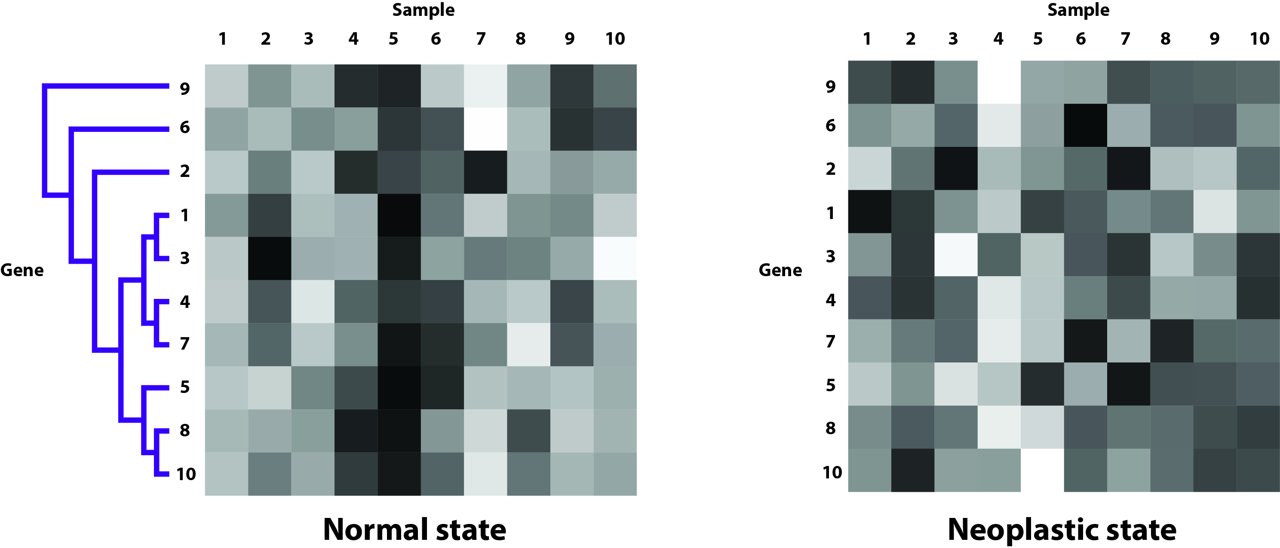

We randomly select 10 samples from normal and neoplastic states to form two 10X10 expression matrices respectively. We believe that gene expressions of normal state tend to conform to a peculiar pattern, which can be identified when genes are clustered. In contrast, such pattern is less obvious in neoplastic state. We intend to demonstrate such contrast by comparing the gene expression patterns of normal state with that of neoplastic state. Figure 6 shows the distinctive gene expression matrices of normal and neoplastic state. The dendrogram indicates the normal state’s hierarchical clustering (HCL) result across ten genes by average linkage clustering of Pearson correlation [30]. For better comparison, we realign the order of genes in neoplastic state, making it consistent with the normal state. In both states, each gene expression value is normalized according to the mean and standard deviation of each row (appendix data). Subsequently, we assign 16 grayscale levels to reflect the normalized gene expression intensity. In Figure 6, the brighter the square appears, the higher gene expression it indicates, and vice versa. As we can see in Figure 6, the grayscale levels in normal state’s clustered genes adhere to similar pattern across different samples, whereas the same genes in neoplastic state fail to follow any patterns. Specifically, the squares in normal state’s Gene 8 and 10 yield very cohesive patterns; gray in sample 1, 3, 9, and 10, dark in sample 4, 5, 8, and bright in sample 7. This observation, however, is less noticeable in neoplastic state’s Gene 8 and 10. Ultimately, through understanding of such patterns, gene co-expression network may be unfolded.

Reference

31. Johannes Rainer, Fatima Sanchez-Cabo, Gernot Stocker, Alexander Sturn, and Zlatko Trajanoski CARMAweb: comprehensive R- and bioconductor-based web service for microarray data analysis Nucl. Acids Res. (1 July 2006) 34 (suppl 2): W498-W503 doi:10.1093/nar/gkl038